# Bug Report

## Bug Title: Accepts Whitespace in the name field of the “Contact Us” page.

### **Bug Id:**

Bug ID: B_001

Reporter: Sijan Dev

Submit Date: 07-03-2024

### **Bug Overview:**

Summary: I can submit the contact us form when I input only whitespaces in the name field.

URL: <https://dev.spirathon-2024.spiralogics.net/#/contact-us>

Screenshots:

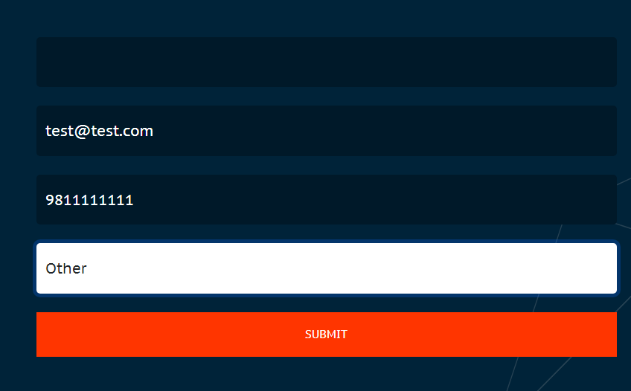



### **Environment:**

Platform: Lenovo Legion 5

OS: Windows 11 Home

Browser: Chrome

### **Bug Details:**

Steps to reproduce:

* Navigate to the URL <https://dev.spirathon-2024.spiralogics.net/#/contact-us>.
* Input at least one whitespace in the name field.
* Enter a valid email address.
* Enter a valid number.
* Select an option to choose “How did you know about us?”
* Enter the Submit button.

Expected Result: Error message should be displayed.

Actual Result: The form was submitted successfully.

### **Bug Tracking:**

Severity: Low

Priority: Low

Impact: Someone can use it to flood the company’s email.

## Bug Title: Accepts Whitespace in the different fields of the “Register Team” page.

### **Bug Id:**

Bug ID: B_002

Reporter: Sijan Dev

Submit Date: 07-03-2024

### **Bug Overview:**

Summary: I can register the team by only inputting whitespaces in the following fields:

* Team Name Field.
* Team Leader/Member’s Name Field.
* Academic Institution Field.
* Project Title & Description.
* Tool & Reason for using the tool.

URL: <https://dev.spirathon-2024.spiralogics.net/#/myteam>.

Screenshots: 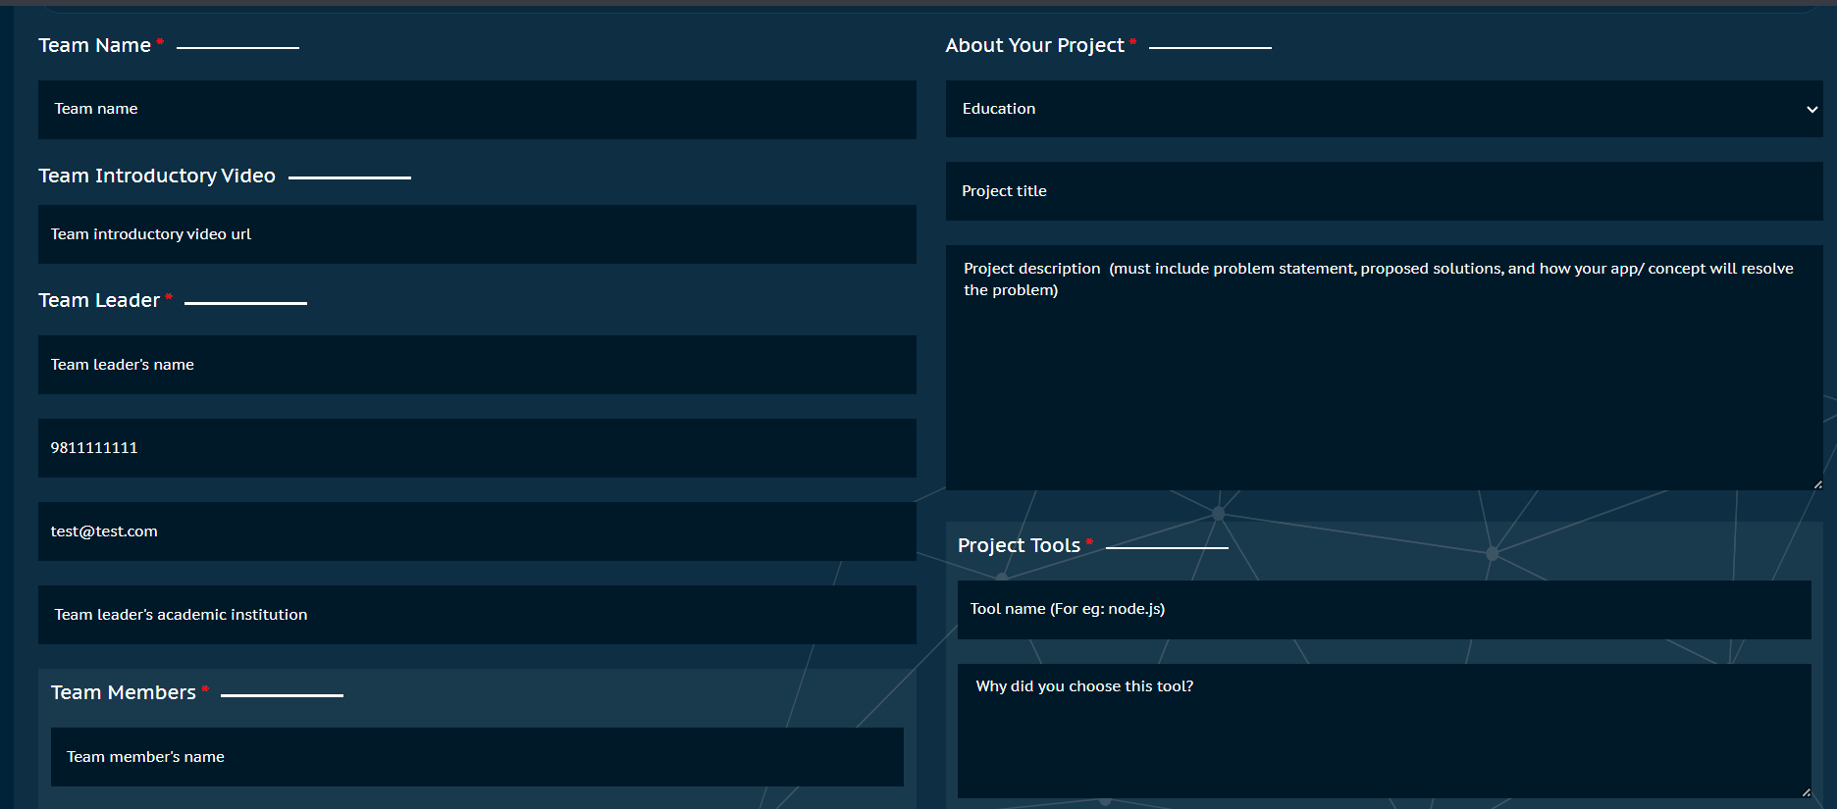

### **Environment:**

Platform: Lenovo Legion 5

OS: Windows 11 Home

Browser: Chrome

### **Bug Details:**

Steps to reproduce:

* Navigate to the URL <https://dev.spirathon-2024.spiralogics.net/#/myteam>.
* Input at least one whitespace in the above-mentioned fields.
* Enter valid information in other fields.
* Enter the Save & Submit button.

Expected Result: Error message should be displayed.

Actual Result: The form was submitted successfully.

### **Bug Tracking:**

Severity: Mid

Priority: Low

Impact: Someone can use it to overwhelm the database.